

Document Title: | Raising and Submission of Sourcing Request Form (SRF)
Document Number: | SCD-PSP-PRT-WI-01
Revision Number: | 01
Prepared by: | Lester Toledo – Assistant Manager, FF&E and Renovation, Procurement and Strategic Planning
Reviewed by: | Revelina Basada – Manager, Quality Management System and Strategic Planning/Execution
Approved by : | Shellame Palaganas – Senior Manager, FF&E and Renovation, Procurement and Strategic Planning
Effectivity Date: | April 26, 2021

- REFERENCE SOP or GUIDELINE: Source to Procure (SCD-PSP-PRT-OP-001, 4.1.1, 5.1.1)

- RESPONSIBILITY

  - Business Unit
    - Input the following details/information correctly on the SRF:
- Name of Requester
- Required Date (based on expected initial delivery date)
- Ringi No. (for ringi-approved items)
- Business Purpose (reason/intention of request)
- Attachment(s) (indicate type by ticking one of the four boxes)
- Name of Department/Division Head of the requesting department/division

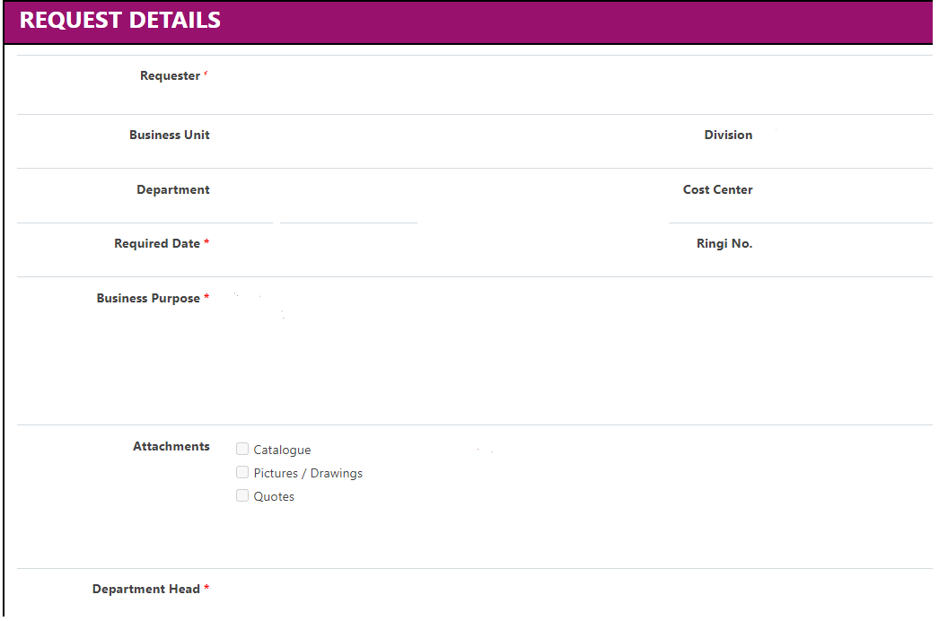

    - If providing a suggested vendor, indicate the vendor’s name, contact person, contact number, and email address.
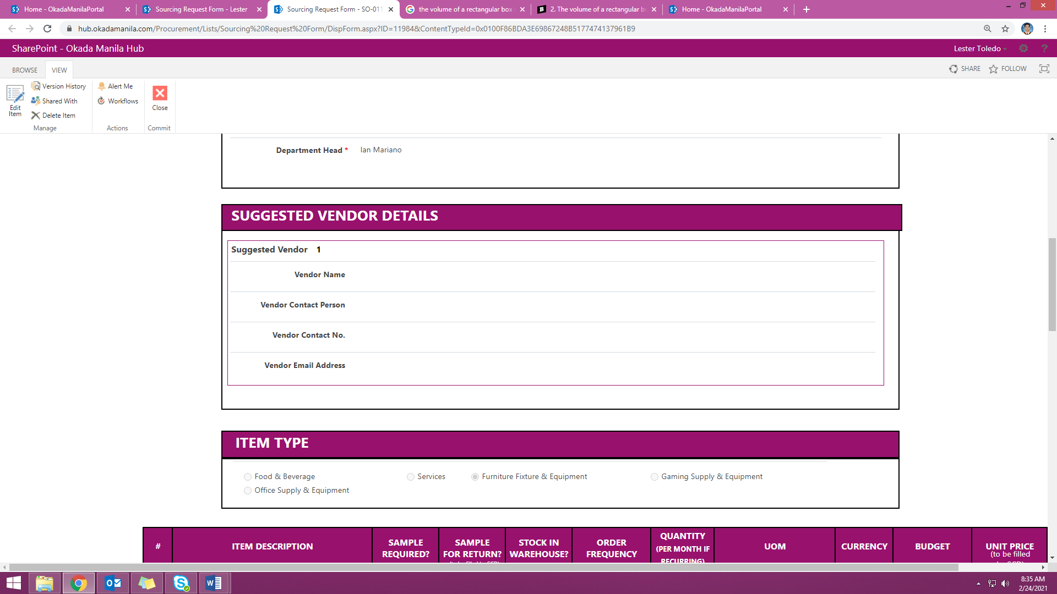
*For multiple suggested vendors, click the ‘add new row’ options to have additional field for suggested vendors.
    - Identify the item type as per below classifications:
- Food & Beverage - Includes fresh, prepared foods as well as packaged foods, and alcoholic and nonalcoholic beverages.
- Operating Supplies & Equipment – Including but not limited to, all the small equipment which is manufactured off-site and mostly, if not all, does not require any installation. Most of the non- food consumables that fall under this category is ‘off the shelf’.
- Services - Requirements relating to contract services, repair and maintenance, marketing events and ad agencies, and other third party service contracts.
- Furniture, Fixtures & Equipment – Requirements relating to fit-outs and renovations. It also includes all the property furniture, furnishings, and depreciable heavy equipment.
- Gaming Supply & Equipment – Requirements relating to materials and spare parts used in Table & Electronic Games.
    - Indicate the following details of item(s) correctly:
- Complete specification of the requirement (including but not limited to item description, dimensions and sizes, color, packaging style, and brand)
- Sample Requirement (yes or no)
- Stock in Warehouse Instruction
- Order frequency (recurring or one time)
- Quantity (per month if recurring)
- UOM (Unit of Measurement)
- Currency (to be used for budget and unit price)
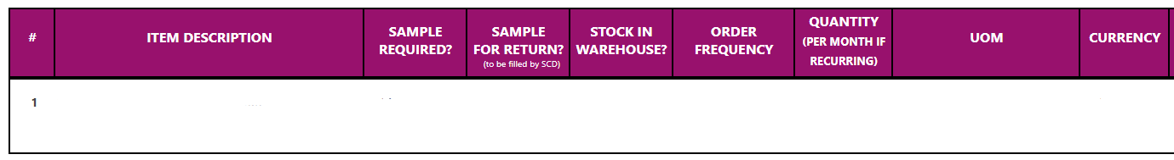

*To create new line item, click ‘add new row’ option.
*To delete the whole line item, click the ‘x’ option on the right most part of the line item.

    - On the ‘Additional Remarks’, indicate the following applicable details:
- Special requests/comments
- Limitations or things to avoid while sourcing the item (e.g. specific brands)
- If reorder, previous PO reference number.
- If previously cancelled, must indicate previous SRF number.

    - Check and review all the details provided. Ensure that all are correct and complete prior to saving changes.

    - Click the ‘Save’ button to finish SRF submission.
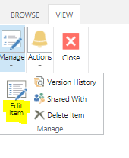

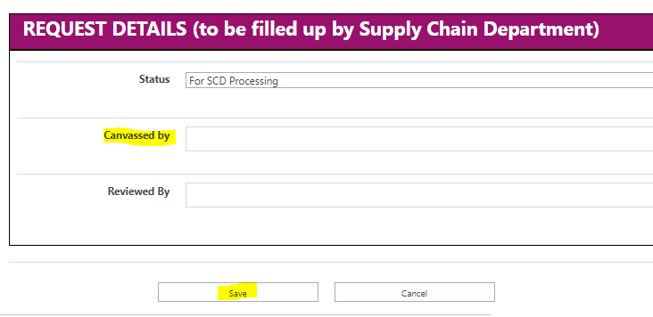

- PROCEDURE DETAILS:

  - Business Unit to access on Share point the Sourcing Request Form (SRF) and correctly provided the details necessary for SRF processing.
  - If primary details and crucial information of request are already provided and reviewed, Business Unit to finalize SRF and save changes to route SRF for SCD processing.
  - Business Unit to send an email notification to respective Procurement Manager (aligned with item/request classification) that SRF has been raised and ready for SCD processing.

- FORMS:

- Sourcing Request Form (SRF)

- REVISION HISTORY

Revision No. | Effective  Date | Reason of Revision | Prepared by | Reviewed by | Approved by
00 | 18-Dec- 2019 | Initial | C. Menor | R. Basada & J. Baranda | R. Aguas Jr.
01 | April 26, 2021 | - Revision of QMS Approval Matrix  - Change of Document Number from SCD-PSS-SYS to SCD- PSP-PRT and number sequence | L. C. Toledo | R. Basada | S. Palaganas

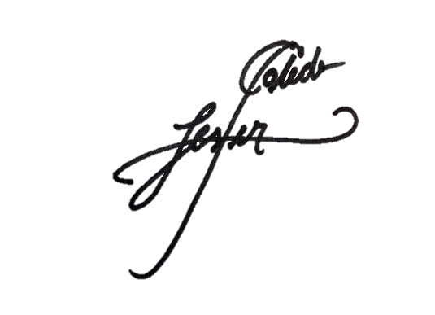  Prepared by:  __________________________  Lester Toledo  Asst. Manager, FF&E & Renovation, Procurement  and Strategic Planning | Reviewed by:  _________________________  Revelina O. Basada  Manager, QMS and Strategic  Planning / Execution | Approved by:  _________________________  Shellame P. Palaganas  Senior Manager, FF&E & Renovation, Procurement and Strategic Planning

